You will create a form's app that accepts text entry from the user, and converts the text to Pig Latin.  You will require knowledge from chapters 1-9 for this project.

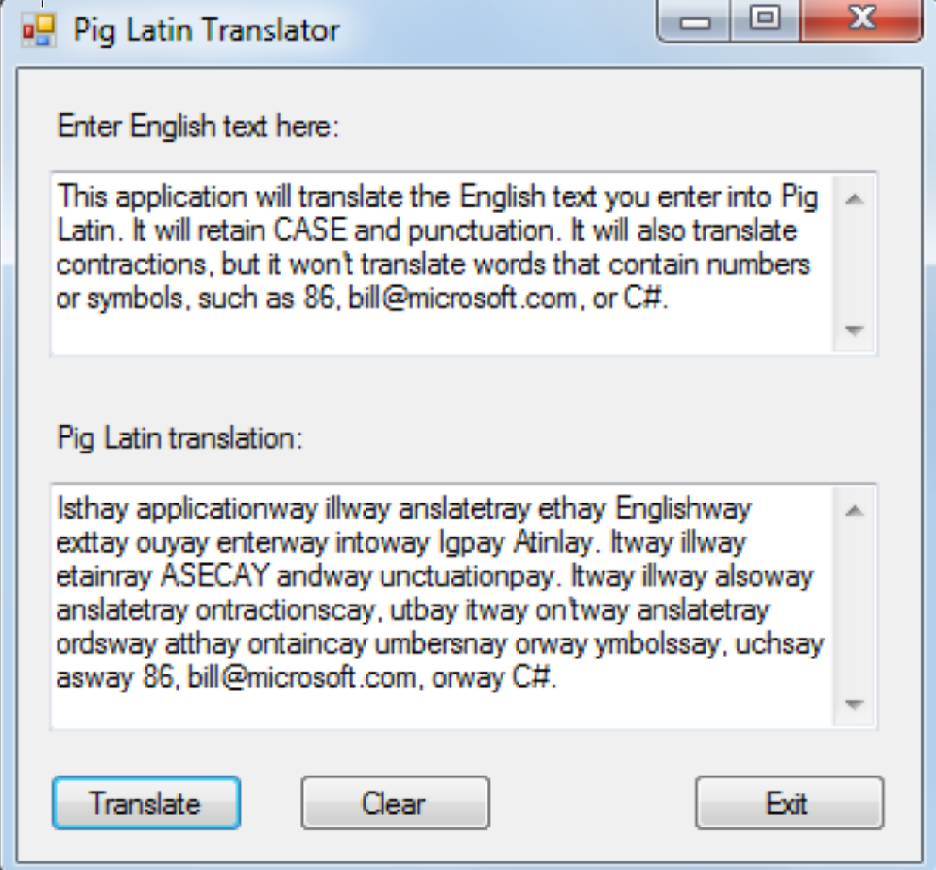

**Operation**

* The user enters text in the first multi-line text box and clicks the Translate button or presses the Enter key.
* The application translates the text to Pig Latin and displays it in the second multi-line text box.
* To clear both text boxes, the user clicks the Clear button, or hits the escape button.

**Specifications**

* If a word starts with a vowel, just add way to the end of the word.
* If a word starts with a consonant, move the consonants before the first vowel to the end of the word and add ay.
* If a word starts with the letter Y, the Y should be treated as a consonant. If the Y appears anywhere else in the word, it should be treated as a vowel.
* Keep the case of the original word whether it’s uppercase (TEST), title case (Test), or lowercase (test).
* Keep all punctuation at the end of the translated word.
* Translate words with contractions. For example, can’t should be an’tcay.
* Don’t translate words that contain numbers or symbols. For example, 123 should be left as 123, and bill@microsoft.com should be left as bill@microsoft.com.
* Check that the user has entered text before performing the translation.
* Solution & Project should be named StudentNumberA2 (IE 123123123A2)
* The unit test project should be named StudentNumberA2_Tests (IE 123123123A2_Tests)
* Submit a zip file named StudentNumberA2.zip (ie. 123123123A2.zip) which extracts a folder named StudentNumberA2 (ie 123123123A2) which contains your sln file, and project folder with its applicable files inside.
* Code must be Unit tested, and the unit tests appropriately documented